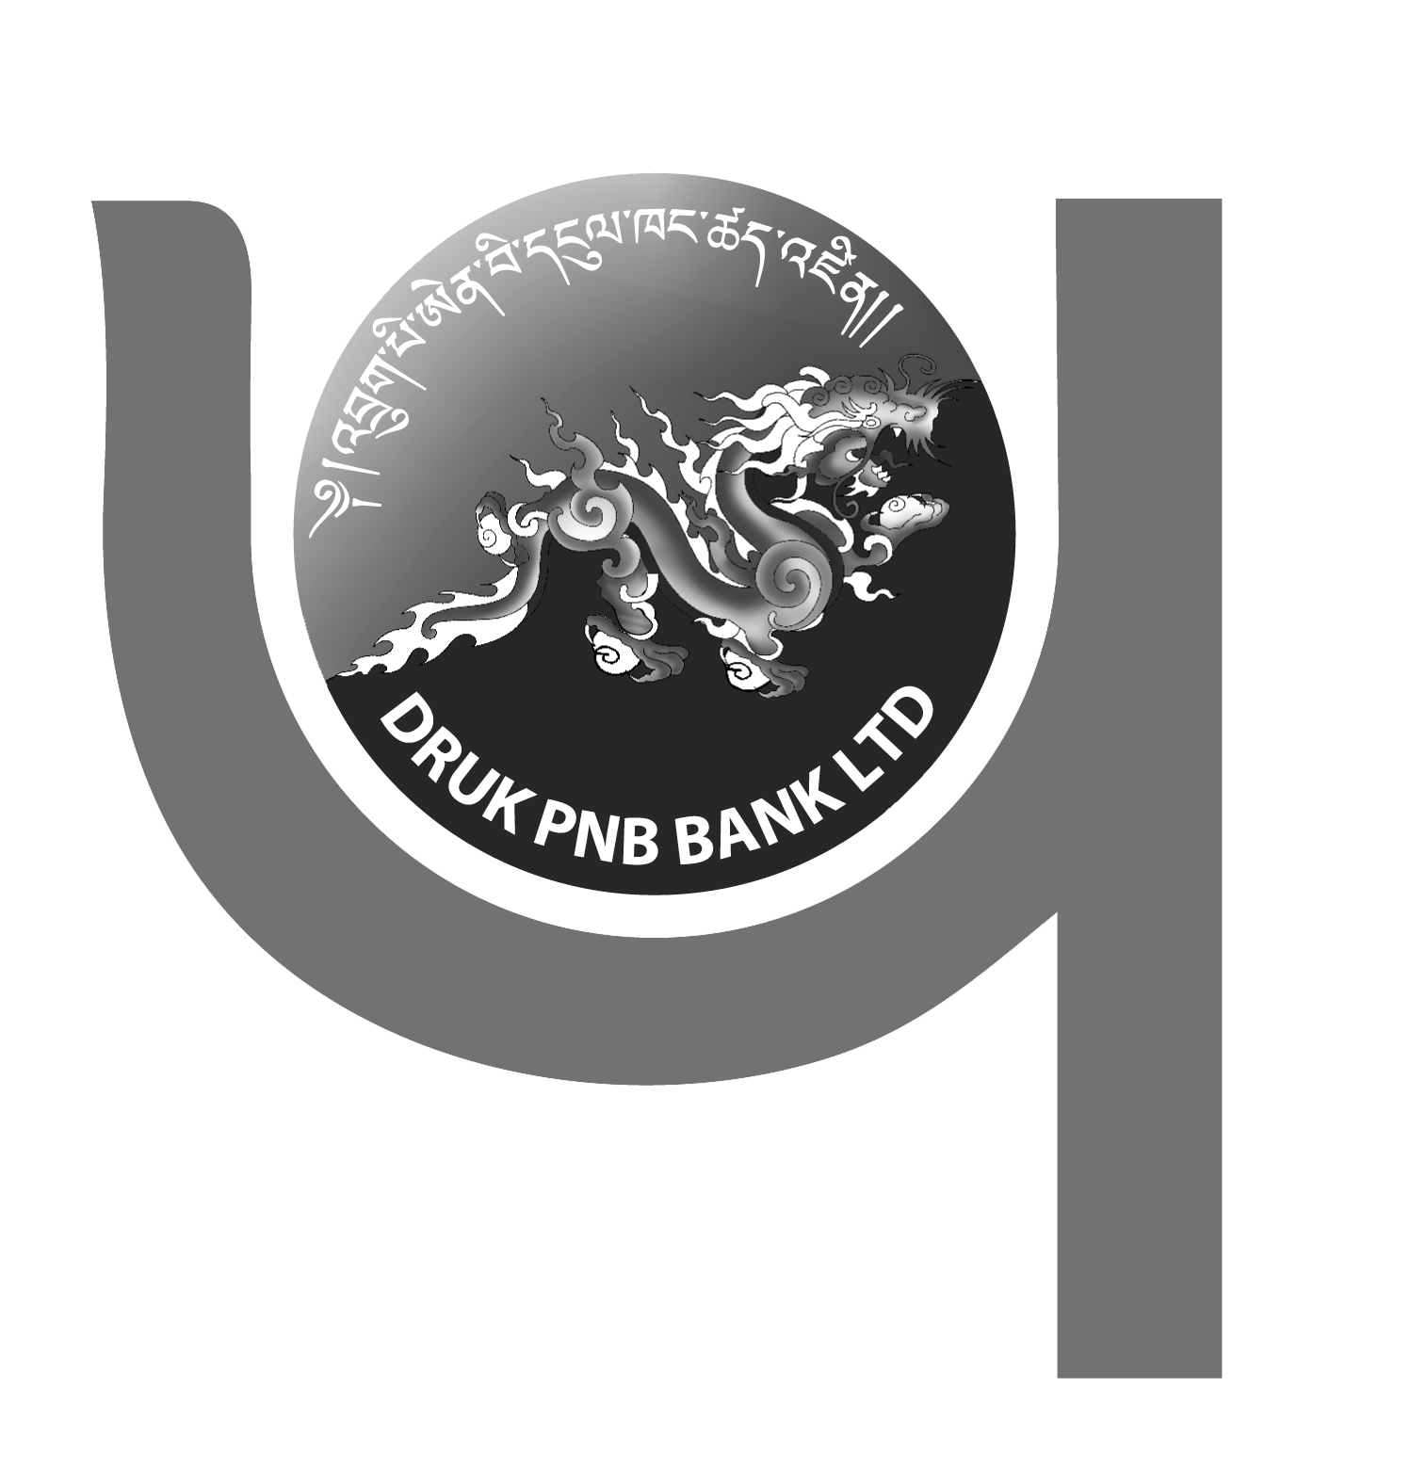
DRUK PNB BANK LTD
..your partner in growth!



NOTICE TO SHAREHOLDERS

This is to notify all valued shareholders of Druk PNB Bank Ltd., that they are requested to update their Taxpayer Number (TPN) and valid bank account details for Dividend Payment 2025.

The shareholders may visit any of the branches during office hours to complete the update process.

For further details or assistance, please contact us at our Toll Free Number 1313 during office hours i.e. Monday to Friday from 9:00 am to 5:00 pm.

MANAGEMENT

