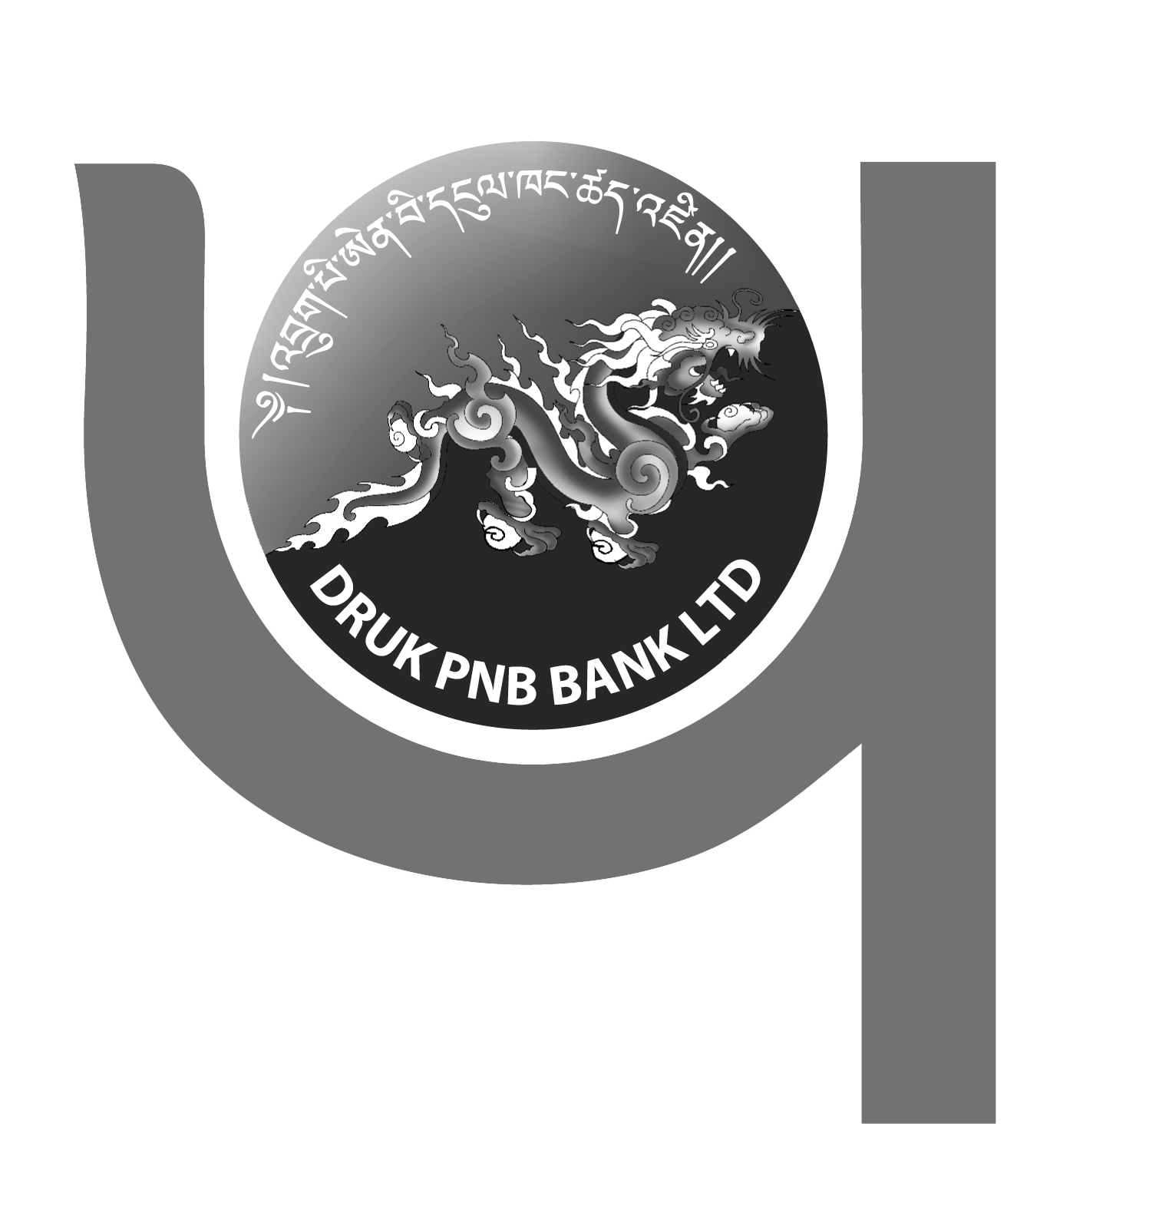
DRUK PNB BANK LTD
..your partner in growth!



DIVIDEND and BONUS SHARES ANNOUNCEMENT

This is to notify all the valued shareholders of Druk PNB Bank Ltd., that the General Body of the shareholders in its 16th Annual General Meeting held on 23rd March 2026 has approved a dividend of 5% and bonus shares in the ratio of 1:6 for the year 2025.

The record date for the disbursement of dividend has been set on 22nd May 2026.
Dividend payments will be made directly to your registered Bank Accounts.

The shareholders are requested to update their valid bank account number with RSEBL office in Thimphu during office hours.

For further details, please contact us at our Toll Free Number 1313 during office hours i.e Monday to Friday from 9:00 am to 5:00 pm

MANAGEMENT

